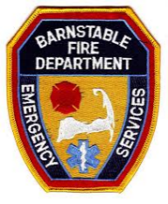
COMMERCIAL
Rapid Entry System Order Form
This form must be filled out completely or your order will be delayed.
*All Kidde Safes come with black polyester powder paint, wall anchors and bolts.
Check Item to Order | Item Number / Description | Price / Each | Total w/Shipping & Tax
 | 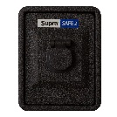SKU/Part # 524314  SupraSafe 2HS Heavy Duty Lockbox  5” H x 4” W x 3 ¼ ” D  Commercial | $499.97 | $543.93
*All lockboxes are shipped without keys. Contact the Fire Department for information concerning keys and lockup. Mounting instructions will be included with your order. Check the item or items above that you would like to order and return this form with a check payable to BARNSTABLE FIRE
*If you are ordering more than (1) please call for the total with shipping/handling/tax.

Name: ____________________________________________________________________
Address: ____________________________________________________________________
____________________________________________________________________
____________________________________________________________________
Phone #: ____________________________________________________________________
Attach your payment to this order form and return to:

BARNSTABLE FIRE DEPARTMENT
attn: KAREN HICKEY
PO Box 94
Barnstable, MA 02630

Your order will be shipped to the Barnstable Fire Department. We will contact you as soon as your order has been received.

Please note – Supply chain disruptions have caused production delays on Kidde Lockbox orders. All current and new orders will be delayed for up to approximately two months.

