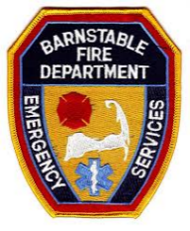
RESIDENTIAL
Rapid Entry System Order Form
This form must be filled out completely or your order will be delayed.
*All Kidde Safes come with black polyester powder paint, wall anchors and bolts.
Check Item to Order | Item Number / Description | Price / Each
 | 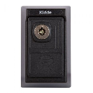Titan 2 Part # 002087  S5 Lockbox Wall Mount w/Dry Lock Lid  4 ¼” H x 2 ¼” W x 2” D  Residential | $69.70

*All lockboxes are shipped without keys. Contact the Fire Department for information concerning keys and lockup. Mounting instructions will be included with your order, however we would be happy to install/mount your lock box for you.
Return this form with a check payable to Barnstable Fire - $69.70.

Name: ____________________________________________________________________
Address: ____________________________________________________________________
____________________________________________________________________
____________________________________________________________________
Phone #: ____________________________________________________________________
Return to:

BARNSTABLE FIRE DEPARTMENT
attn: KAREN HICKEY
PO Box 94
Barnstable, MA 02630

Your order will be shipped to the Barnstable Fire Department. We will contact you as soon as your order has been received.

